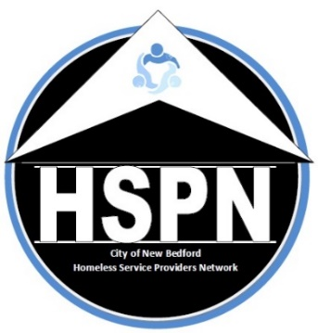
NEW BEDFORD HOMELESS SERVICE PROVIDER NETWORK (HSPN)
Membership Agreement.2022

The mission of the City of New Bedford’s Continuum of Care, as articulated through its Homeless Service Provider Network [HSPN], is to advocate on behalf of individuals and families experiencing homelessness by enlisting the cooperation of homeless providers, allied resources and community partners in order to improve the accessibility of existing public resources, maintain statistical data on the homeless population and provide supportive services and empowerment strategies allowing these individuals and families to be reintegrated into the community through a compassionate Continuum of Care. The HSPN is committed to the concept that each person is entitled to live in dignity. This signed pledge of commitment to participate in the HSPN and its acceptance by the HSPN Executive Board serves as the basis of membership in the HSPN.
www.nbhspn.com

Active membership allows member organizations and those with lived experience a voice in the decision-making progress for issues brought before the HSPN including, but not limited to, the identification of homeless needs and the prioritization of projects for the annual Continuum of Care application. Active membership also allows access to federal homelessness funds from the U.S. Department of Housing and Urban Development administered by the City of New Bedford’s Office of Housing & Community Development (OHCD).

The HSPN meets the third Thursday of every month at the OHCD’s offices located on the second floor of the Anthony S. Catojo Building (Art Museum) at 608 Pleasant Street in downtown New Bedford. Virtual meetings are conducted during periods warranted by a public health crisis. All are welcomed to attend.

Please print agency/org/indiv name:

Address:

City:

State/Zip:

Contact Name: Phone:

Contact Email:

Executive Director/CEO Name:

As a member of the Homeless Services Provider Network the member agrees to:
- Abide by the HSPN Code of Conduct,
- Support all HSPN members in their efforts to provide housing, resources and services to those experiencing homelessness,
- Share information and resources, and
- Share ideas for potential speakers and relevant topics for HSPN meetings

All HSPN non-profit member organizations are eligible to apply for any funds that may become available; final eligibility depends on satisfactorily meeting the required conditions of any funding offered.

Signature: _____________________________________________Date: 1/26/2022

Please Email to: Jennifer.Clarke@newbedford-ma.gov
or Mail to: City of New Bedford’s Office of Housing & Community Development
608 Pleasant Street New Bedford, MA 02740.

